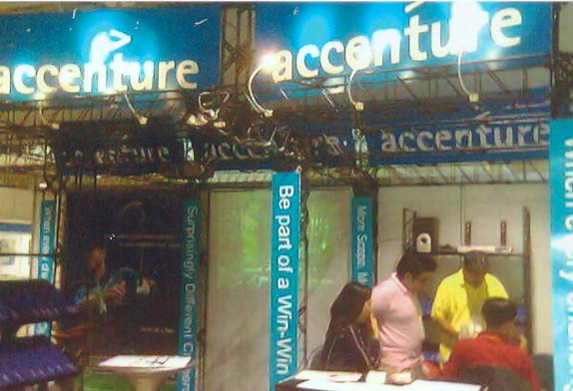
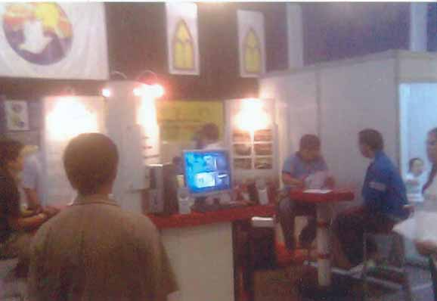
Direct Mailings
Posters
Flyers
Banners
Invitation by Fax, Text Messaging AndTelemarketing

Press Releases
Mass Email Dispatch
Text Blasts
Print Ads and Press Releases
Radio Announcements

‘Mid-Year Recruitment and Selection Campaign”

June 9-10, 2007

EXPO Trade Hall,
4th Floor, Festival Supermall, Filinvest, Alabang

Recruitment and Selection Time
10:00 A.M. – 5:00 P.M.

EVENT’S PERSPECTIVE

The Southern Manila Job Fair 2007, apart from being the year’s primary recruitment event in the south, is for its third term considered to be the biggest gathering of BPO and ICT companies, contact centers, call center staffing firms, communications and language training companies and allied institutions that will advance the usual job fair recruitment procedure to a higher level so that every applicant shall be assessed thoroughly and get their application results within the day.

Advance Recruitment Procedure

Every participating company of the Southern Manila Job Fair 2007will be requested to do the advance recruitment procedure that totally differs from the standard application
processing of most job fairs that reduces the route to just mere resume passing and initial interviews.
According to the survey done by several institutions from media and the recruiting industry, applicants gain more confidence and the companies prevent unnecessary loss of time, effort, and money if such comprehensive method is applied. This is also advisable to prevent the developing psychological effect of the existing process that tires the applicant and makes every job fair an unsure attempt for employment.

Application Process

Initiated by the John Clements Consultants during the first launching of the event on March, 2005 The 2007 Job Fair features 1) on the spot job offers; 2) outright placement and 3 skill matching. The Company was also to bring facilities for computerized testing and additional manpower that let them have a total of 12% on the spot hiring among the pool of competent applicants. As a highlight, the event also had special assistance for applicants in terms of 1) resume writing; 2) oral proficiency; 3) power dressing and organizational culture assimilation.
In continuation of the concepts heaved by the 2005 launch of the event, the participating recruiting companies shall be encouraged to carry the office-route assessment of the applicants to the job fair. In that fashion, by the end of the recruitment hour, we can directly predict the hiring percentage of the applicants general.

TARGET AUDIENCE

The EXPO Trade Hall of Festival Supermall in Alabang attends to different psychographics and various demographical scopes the event reaches through its strategic promotion channeling. As the only accessible area in southern Metro Manila the 4th Floor caters to applicants ranging in class, skills and qualifications. True to its reputation, Alabang is marked to be the center of transportation and travel in Luzon, bridging the north and south conveniently.

As part of the standard event promotion, the organizes sent our flyers, posters and other promotional materials in different sports club, restasaurants, banks, corporations, advertising agencies and other establsihment Metro Manila neraby suburbs.

To further increase the strenght of our promotion, we have cooperated with different schools, colleges, and univesities in the whole NCR and Southern Luzon to encourage their sudents to attend, pass resumes and apply at this event.
Supported by the Public Employment Service Office, through dirct sanction of the Department of labor and Employment, collaterals would be disseminated in different municipalities and barangays of the CALABARZON area long with prime concentration in the south NCR.

MEDIA CHANNELS

Offical event broadsheet partner: The Philippine STAR
Official publications partners: Ang OFW Ngayon
Official radio partners: Joey 92.3
RJ 100
Official on-line partners: ClicktheCity.com
Trabaho.com
CareerCare.com.ph
Othe promotional route/ Ayala Alabng Village
Allied media Publication
Village Voice
NTFI
PROMOTIONAL TOOLS
To further assure widespread information dissemination we incorporate the use promotional tools like:

The Southern Manila Job Fair 2007
is an Advocacy event of PHILTRADE Exhibits
8253482 * 8264291 * 09208766505
philtradeevents@yahoo.com.ph

- Ayala Alabang
- Alabang Hills
- Alabang 400
- BF Homes Parañaque
- BF Resort Executive Row
- Citadella Subdivision 1
- Southbay Homes
- Italia 500
- Kalipayan Village

- New Sun Valley
- Marian Bay Homes
- Maywood 1
- Pacific Malayan
- Pacific Village
- Philamlife Village
- Tahanan Village
- Teoville 1 & 2
- Tierra Nueva

